Ambient Radiation Reusability Package Overview
The Ambient Radiation Reusability Package is intended to serve as a “one stop resource guide” for data providers who are interested in publishing their radon data on the Exchange Network (EN), or data consumers who are interested in retrieving and analyzing ambient air radiation data that has been published on the EN.

The following files are included in this package:

File Name | Description | Prerequisites
Ambient Radiation Outreach Visio | Provides an overview of NJDEP’s approach to publish and share their data on the EN. Reusable components and assets from their previous implementations are identified and described in this document. | N/A
AQS XML Schema (v2.2a) | Defines the form and structure of the Air Quality System data exchange. | N/A
AQS DET (v2.2a) | The MS Excel AQS Data Element Template (DET) should be used in conjunction with the AQS XML Schema, and describes the definitions and validation rules associated with each element in the schema. | N/A
AQS FCD (v2.2a) | The AQS Flow Configuration Document (FCD) identifies the protocols for exchanging Ambient Radiation data on the EN. | N/A
How To Publish Data Guide | Describes how to publish and register data on the Exchange Network Discovery Service (ENDS), a central repository created by the EPA to store and catalog Node services, parameters, and parameter values supported by EN partners | N/A
NJDEP’s ENDS Service Registration XML file | NDJEP’s ENDS Service Registration file defines the parameters (e.g. filter criteria) that are supported by DEP’s services. Data that is registered in the ENDS repository is made available to the EN Browser, an EN data discovery and analysis tool. | N/A
NJDEP’s ENDS DEDL Registration XML file | NDJEP’s ENDS Data Element Definition Language (DEDL) Registration file defines the pick list values supported by each of the parameters specified in the Service Registration file. | N/A
NAAS Security Process Documentation | Provides instructions on how to obtain a NAAS account. | N/A
NAAS Toolkit | The NAAS Toolkit provides an online interface for users to verify and test their access to a particular Node by sending an authentication web service request to the Node’s endpoint.  Test NAAS Toolkit: https://naas.epacdxnode.net/  Production NAAS Toolkit: https://cdxnodenaas.epa.gov/ | A valid NAAS account is required to use the NAAS toolkit.
NodeFunctionalSpecification_v2.1 | Provides the protocols and specifications that govern Node 2.0 data exchanges. | N/A
Node Web Service Sample Code | Sample code describing how to construct Node 2.0 web service calls such as authenticate, query, solicit, getstatus, download, etc. | - Visual Studio 2008 and up  - Web Services Enhancements (WSE) 3.0 for Microsoft .NET: http://www.microsoft.com/en-us/download/details.aspx?id=14089

How to Use the Files

Data Publishing
Data publishers who are interested in exchanging their Ambient Radiation data with the EPA or creating a Ambient Radiation service (e.g. Solicit or Query) should reference the following documents/files:
- Ambient Radiation Outreach Visio
- AQS XML Schema
- AQS DET
- AQS FCD

Data providers who are seeking to make their data available to the EN Browser by publishing their service(s) at ENDS should reference the following documents/files:
- How to Publish Data Guide
- NJDEP’s ENDS Service Registration XML file – Data Providers may use this example file as a basis and guide for registering their own service(s) and service parameters
- NJDEP’s ENDS DEDL Registration XML file – Data Providers may use this example file as a basis and guide for registering their own service parameter values

The ENDS Test and Production websites can be accessed via the links below.

ENDS Test: https://ends2.epacdxnode.net/
ENDS Production: https://ends2.epa.gov/

A Network Authentication and Authorization Service (NAAS) user account is required to login to ENDS.

In addition, the EPA’s NAAS, Central Data Exchange (CDX) Node, and ENDS technical support information is provided below.

Email: nodehelpdesk@epacdx.net
Phone: 877-827-0260

Data Consumers

Using the ENB to Retrieve and Analyze Data
Individuals who are interested in discovering, retrieving and analyzing data that has been published on the EN may use the EN Browser (ENB) tool, a free EN data discovery and analysis tool hosted by the Environmental Council of States (ECOS).

The ENB tool can be accessed here: http://www.enbrowser.net/

The ENB is open to the general public and authorized NAAS users, and does not require login credentials to use the tool. Users who do not login to the application will automatically be signed on as the Guest account user. The Guest account will have access to “Active” services denoted with a green “A” in the application.

Users may also choose to login to the application using their NAAS account credentials to access services that they have been granted specific access to by the data provider.

To learn more about the ENB, interested individuals may access the Online Help Videos located under the “Help” link.

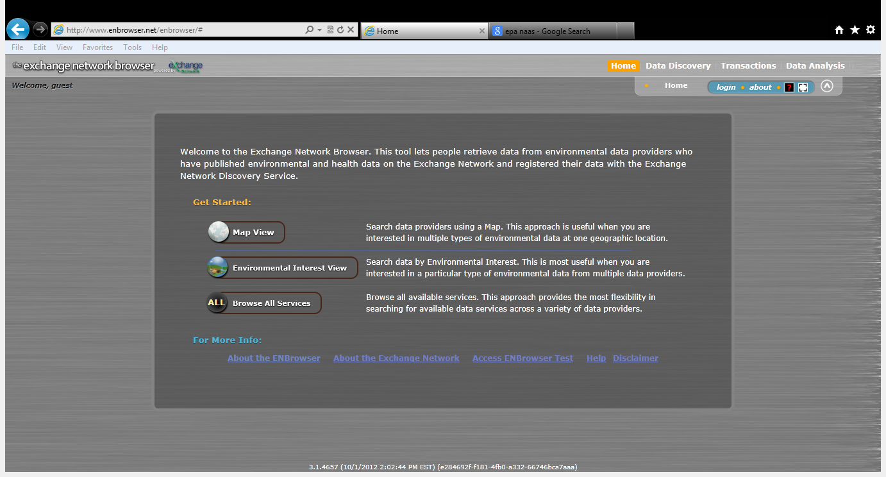

Retrieving Data through Web Services
Individuals who are interested in retrieving data from EN Partners through web services may reference the steps detailed below.

- Obtain a NAAS account. Individuals may reference the NAAS Security Process Documentation for detailed instructions on how to obtain a NAAS account.

- Contact the data provider to request access to the data provider’s Node. Individuals who are interested in retrieving NJDEP’s data may contact Mike Matsko at Mike.Matsko@dep.state.nj.us

- Once access has been granted by the data provider, use the NAAS toolkit to verify your access to the Node.

- Construct your web service call to request data from the Node. Individuals may reference the Web Service Sample code for additional information. The following web service methods are typically executed to retrieve back data:
  - Authenticate: The authenticate method is used to verify that the individual has access to the data provider’s Node and Service(s)
  - Solicit or Query: The Solicit web service method can be used to retrieve back large data sets in an asynchronous fashion. The Query web service method can be used to retrieve back small sets of data (less than 3-4 MB).
  - GetStatus: Used to identify the status of transaction (e.g. processing, downloaded, etc.)
  - Download: Used to download the file generated by the data provider’s Node.

