#### Cover01

ER3 User Guide

Environmental Response Resource Registry (ER3) System

Version: 1.0

May 16, 2012

Logo

1368 How Lane

North Brunswick, New Jersey 08902

Telephone: (732) 839-1688 • Fax: (732) 214-8619

[www.enfotech.com](http://www.enfotech.com)

Table of Contents

1 Introduction 4

1.1 Overview 4

2 User Account Creation 5

2.1 Request an Organization Manager User Account 5

2.2 How to Create an Organization User Account 7

3 ER3 Homepage 9

4 Organization Management 11

4.1 Modify Basic Information 11

4.2 Modify Site List 12

4.3 Resource Overview Tab 13

4.4 Modify Contact List 14

5 Resource Management 15

5.1 Resource Search 15

5.2 Add a New Resource 16

5.3 Subcontract Out a Resource 17

6 Profile Management 19

**Listing of Figures**

**Figure 1: ER3 Login Page** 5

**Figure 2: ER3 Account Request: Organization Information** 6

**Figure 3: ER3 Account Request: Contact Information** 6

**Figure 4: User Management Module Link** 7

**Figure 5: Create New User Screen** 8

**Figure 6: ER3 Homepage** 9

**Figure 7: Organization Search** 11

**Figure 8: Add a Response Type** 12

**Figure 9: Owned Resource View** 13

**Figure 10: Contracted Resource View** 13

**Figure 11: Contact Tab** 14

**Figure 12: Resource Management Quick-link** 15

**Figure 13: Resource Basic Information tab** 16

**Figure 14: Resource Manufacturer Specification tab** 17

**Figure 15: Subcontract out a Resource** 17

**Figure 16: Subcontract Resource Details** 18

**Figure 17: Profile Management Module** 19

# Introduction

## Overview

Welcome and thank you for participating in the Environmental Response Resource Registry (ER3) initiative!

The ER3 initiative is a collaborative effort between the Great Lakes Commission, Michigan DEQ, Wisconsin DNR, and enfoTech to establish a central inventory of response resources for responders to tap into in the event of a chemical or oil spill accident.

Two systems have been implemented by the ER3 team to help support oil and chemical spill contingency planning and response:

* ER3 Application UI: An open web-based application that enables spill response resource providers (e.g. Federal, State, Local, Commercial Agencies, etc.) to share and submit response resource data to the ER3 Database. Spill responders may use the ER3 application to help maintain, track, and manage their resource inventories. Response resource data in the ER3 database will be made available and published to the Exchange Network Browser.
* EN Browser: A web-based tool that enables data consumers to search for and analyze response resources. This tool can be used to search for and pinpoint the location of available resources in the event of a spill accident.

This document will serve as the user guide for the ER3 Application UI. It is intended to help familiarize the end user with the ER3 application, and provide guidance on the system functions and features. The following topics will be covered:

* User Account Creation
* Homepage Configuration
* Organization Management
* Resource Management
* User Profile Management

# User Account Creation

The ER3 system supports two general user roles for response resource providers. These are:

1. ER3 Organization Manager User: Each organization must have at least **one** ER3 Organization Manager Account. The ER3 Organization Manager user will serve as the primary representative of the resource provider, and will be responsible for creating and managing ER3 Organization user accounts associated with their organization or company. This role possesses the following system rights:
   1. The ability to create additional Organization User accounts on behalf of his or her organization
   2. The ability to search, edit, and add information in the Organization and Resource modules
2. ER3 Organization User: The Organization User possesses the ability to manage his or her organization’s response resource inventory. This user role possesses privileges to search, edit, and add information in the Organization and Resource modules.

## Request an Organization Manager User Account

The steps below outline the process for requesting an Organization Manager User account:

1. In the ER3 login page, click the “Request an ER3 Account” link.

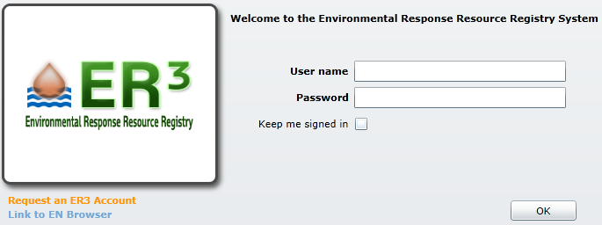

**Figure 1: ER3 Login Page**

1. Specify the required fields under the Organization Information and Contact Information sections, and click “Submit”.

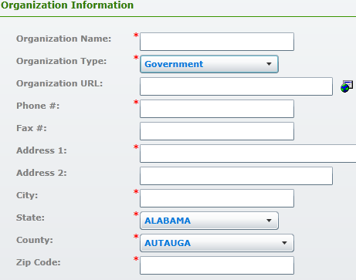

Format: 8005551111

Select the option that best matches your Organization

**Figure 2: ER3 Account Request: Organization Information**

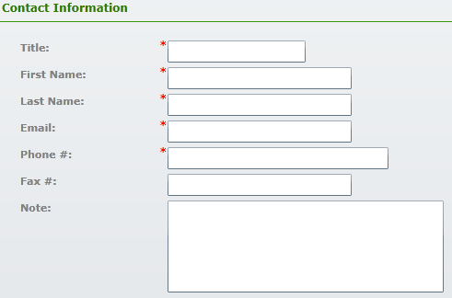

Format: 8005551111

(e.g. Mr., Mrs., etc.)

**Figure 3: ER3 Account Request: Contact Information**

Once your application has been reviewed and approved by the System Administrator, an email containing your username and password will be sent to you.

## How to Create an Organization User Account

Once you have obtained an Organization Manager User account, you may create additional system accounts for other members of your company or organization.

Please reference the steps to create an Organization User account:

1. Login to the system using your Organization Manager User account.
2. Upon login, navigate to the User Management module.

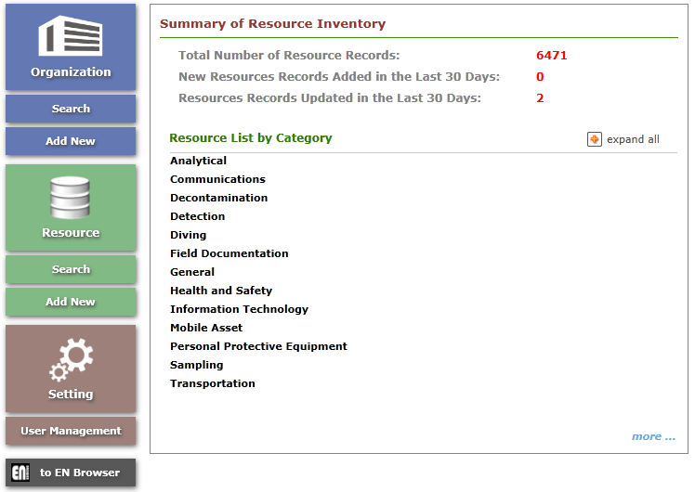

**Figure 4: User Management Module Link**

1. Click the  button.
2. Specify the User name (e.g. login name for the new user)
3. Specify the “Friendly name”. This field corresponds to the name that will be displayed in the system when the user logs into the system.
4. Select a user role (Organization User)
5. Select your Organization from the Organization drop-down.
6. Specify the user’s email address.
7. Specify the First, Middle Initial, and Last name fields, and click “Save”. Once the request has been saved, an email containing the user’s account credentials will be emailed to the new user.

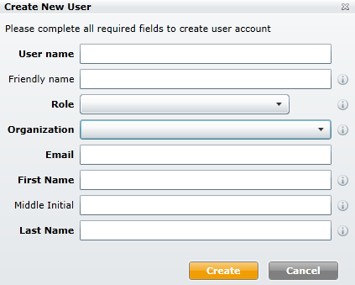

Required fields are highlighted in **BOLD**

**Figure 5: Create New User Screen**

# ER3 Homepage

The ER3 Home page provides many web-parts and quick access links to allow the end user to have direct “quick access” to the desired functional areas to perform his or her daily job functions.

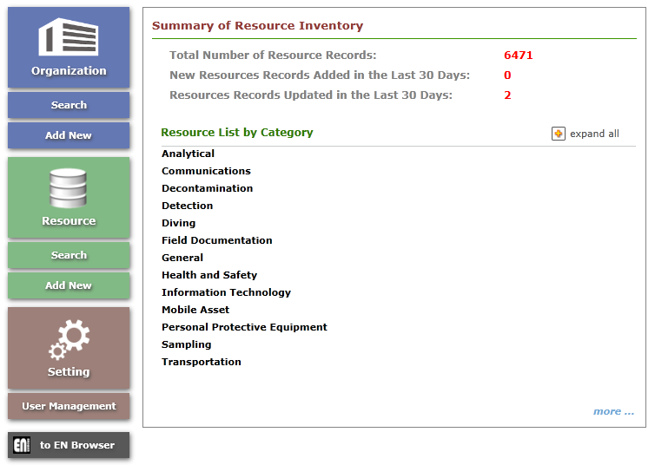

**Figure 6: ER3 Homepage**

Below are the brief functional descriptions of each web-part block or icon link:

1. Summary of Resource Inventory: This web-part provides an overview of the resources stored in the ER3 system for your organization. You can view a breakdown of the resource inventory in the “Resource List by Category” section. The resource classifications can either be expanded or collapsed by clicking on the  or  buttons.
2. Organization Quick Links: These icons provide quick links for the end user to navigate to the following pages:
   * Organization Search: Allows the user to search for, filter and edit his or her organization data.
   * Add New Organization: The interface that allows the user to create a new organization in the system.
3. Resource Quick Links: These icons provide quick links for the end user to navigate to the following pages:
   * Resource Search: Allows the user to search for, filter and edit his or her resource data.
   * Add New Resource: The interface that allows the user to create a new resource in the system.
4. Settings Quick Links: These icons provide quick links for the Organization Manager user to navigate to the following pages:
   * User Management: Provides an interface for the user to search for, add, and/ or edit existing user account information.
   * Note: The system accounts with standard Organization User rights will not have access to this module.
5. EN Browser Quick Link: This link directs the user to the EN Browser application, which can be used to discover, search for and analyze response resources.

# Organization Management

The Organization Management module tracks the following information:

* Basic Information (e.g. Organization Name, URL, Status, Response Types etc.)
* Site List (e.g. Resource sites that belong to your organization)
* Response Resource Inventory Overview
* Contacts (e.g. Contacts for specific resource sites)

## Modify Basic Information

The steps below outline the process for viewing and/or editing your organization’s basic information:

1. Navigate to the Organization module.
2. Click “Search” to display your organization in the table under the Search Result section.

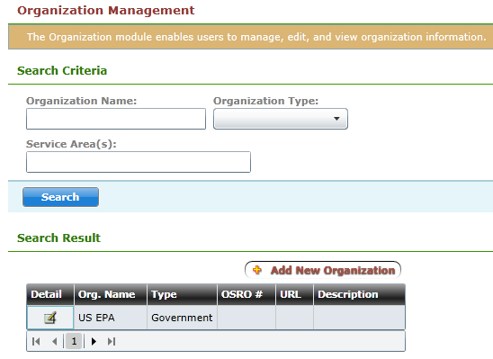

**Figure 7: Organization Search**

1. Click the Detail icon to navigate to the Basic Information tab.
2. You may adjust your Organization’s basic information in the Basic Information section.
3. You may associate response capabilities to your organization by selecting the “+” icon next to “Response Type:” and checking the desired response type values in the “Response Type Selection” window.

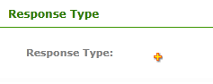

**Figure 8: Add a Response Type**

1. Click “Save” to commit your changes.

## Modify Site List

The Site List tab can be used to track and manage the resource sites (e.g. warehouse, vessels, trailers, headquarter site, etc.) belonging to your organization.

To add a new site:

1. Click the “+” icon next to “Site List”.
2. Specify the following fields in the Basic Information section:
   1. Site Name
   2. Status
   3. Site Type
   4. EPA Region (Note: This field will be determined by the system based on the “State” you specify in the “Location Information” section.)
   5. Site Phone Number
   6. Site Fax Number
3. You may associate your site with a specific service area by clicking the “+” icon, and checking the desired service areas.
4. Specify the following fields in the Location Information section:
   1. Address 1
   2. Address 2 (if needed)
   3. City Name
   4. State
   5. County
   6. Zip Code
   7. Latitude Measure (Note: This field will enable your site to be plotted on a GIS map in the EN Browser. The format is in decimal degrees)
   8. Longitude Measure (Note: This field will enable your site to be plotted on a GIS map in the EN Browser. The format is in decimal degrees)
5. Click “Save” to commit your changes.

Note: To edit the details of an existing site, select the site from the Site List.

## Resource Overview Tab

The Resource Overview tab enables the user to view his or her organization’s response resource inventory in an organized and easy to read fashion.

In this tab, you may filter resources by:

* Site
* Resource Kind
* Availability Status

You may group data by:

* Site
* Resource Category
* Resource Subcategory
* Resource Type
* Resource Kind
* Availability Status

The resource table will automatically adjust based on the criteria you select.

The screen is composed of two main sections. The first section provides an overview of your organization’s “owned resources” (e.g. resources that have not be subcontracted to or contracted from other organizations). The second section provides a view into your organization’s “contracted resource data (e.g. resource(s) that have been contracted from other organizations). The two screens below depict the “Owned Resource” and “Contracted Resource” views.

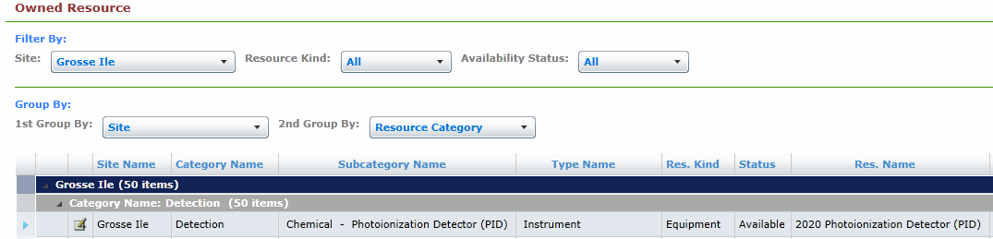

**Figure 9: Owned Resource View**

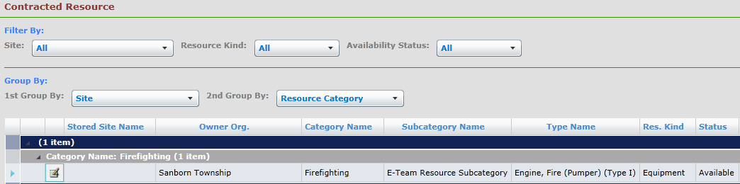

**Figure 10: Contracted Resource View**

## Modify Contact List

Site contacts can be added or modified in the Contact List tab.

To add a new contact:

1. Click the “+” icon next to Contact List.
2. Specify the contact’s first name, last name, email, and office # in the “Basic Information” section.
3. You may associate your contact with a particular site in the “Associated Site(s)” section. You will have the option of assigning your contact as either a “Primary” or “Secondary” contact for your site.

*Note: One site can have multiple primary or secondary contacts.*

1. Click “Save” to commit your changes.

Once your new contact has been saved in the system, the contact will be visible in the “Contact List” pane.

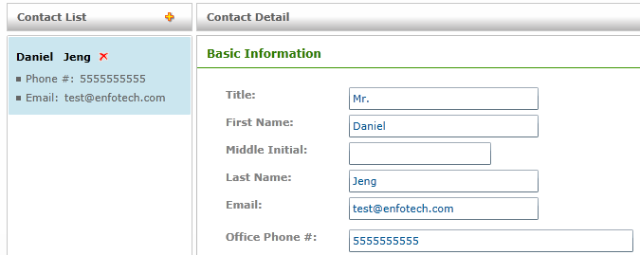

**Figure 11: Contact Tab**

# Resource Management

The Resource Management module provides an interface to allow users to manage their organization’s response resource inventory.

The Resource Management module may be accessed by selecting the quick-link icon on the homepage or the “Resource” icon on the application footer.

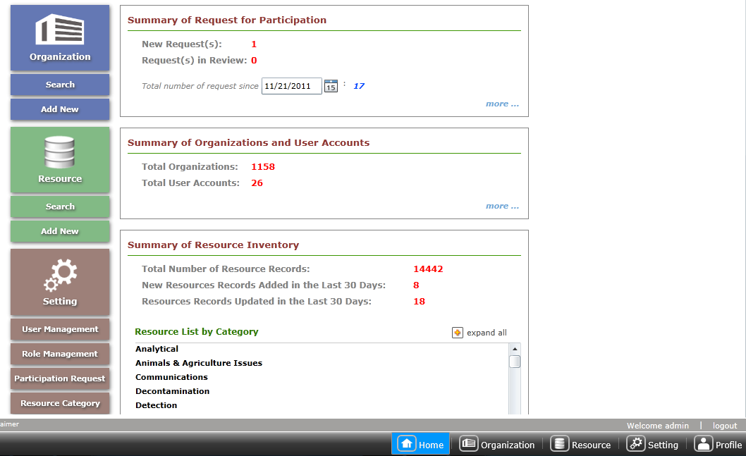

**Figure 12: Resource Management Quick-link**

## Resource Search

The ER3 system supports various filter criteria to allow the user to narrow down his or her resource search results. Descriptions of the supported filter criteria are provided below:

* Organization Name: The organization name.
* Site: The resource site name.
* Service Area: Service areas that your resources sites are associated with.
* State: The state name.
* Resource Name: The name of the resource.
* Resource Category: The resource category classification.
* Resource Subcategory: The resource subcategory classification.
* Response Type: Response capabilities supported by your organization.
* Resource Type: The resource type classification.
* Resource Kind: Identifies the resource as a personnel skill or equipment.
* Availability Status: The availability status of the resource.
* Last Updated Date After: Allows the user to search for all resource updated after a certain date.

## Add a New Resource

To add a new resource:

1. Click the “Add New Resource” link in the Resource Management pane.
2. Specify your resource’s basic information in the “Basic Information” tab. If the required Resource Category, Resource Subcategory, and/ or Resource Type values are not present in the initial drop-downs, you may submit a request to add a new value by clicking the “?” icon

Note: Three resource count numbers are shown on the Basic Information tab. These are:

* **Number Own:** Indicates the number of resources that are owned by your organization.
* **Number On-Site:** Indicates the number of resources that are stored on one of you organization’s resource sites.
* **Available number for Subcontract:** Indicates the number of resources that can be subcontracted to other organizations.

Resource storage site name

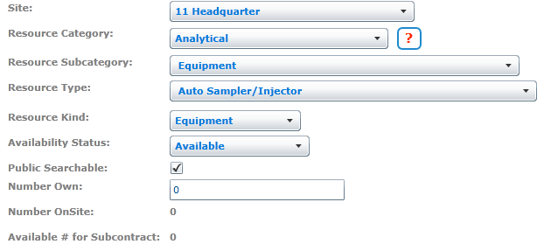

**Figure 13: Resource Basic Information tab**

1. If applicable, you may specify manufacturer specification information for your resource in the “Manufacturer Specification tab”.

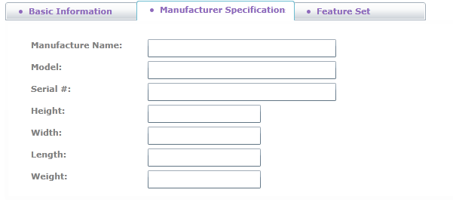

**Figure 14: Resource Manufacturer Specification tab**

1. If a system form has been defined for the selected Resource Type, you may specify additional metadata for your resource in the “Feature Set” tab.
2. Click “Save” to commit your changes.

## Subcontract Out a Resource

The steps below outline the process for subcontracting out resources:

1. Navigate to the resource you would like to subcontract out.
2. Click the “Detail” button to view the resource’s basic information.
3. Navigate to the Basic Information tab, and scroll down to view the “Subcontracted Resource Information” section.
4. Click the “Subcontract” button.

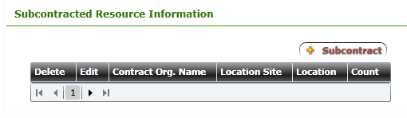

**Figure 15: Subcontract out a Resource**

1. Specify the name of the organization you will be subcontracting your resource to in the “Subcontract Org.” field.

Note: In order to utilize the subcontract function, the organization you will be subcontracting your resources to **must** be registered in the ER3 system. The system will use the first three letters entered into the “Subcontract Org.” field, to display a list of Organization names matching your text.

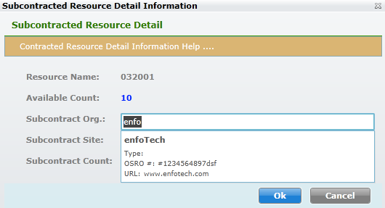

**Figure 16: Subcontract Resource Details**

1. Select the site where the subcontracted resource will be stored in the “Subcontract Site” drop-down.
2. Specify the number of resources you will be subcontracting out in the “Subcontract Count” field.

*Note:* The system will automatically adjust the “Number Onsite” and “Available # for Subcontract” counts based on the number of resources you have subcontracted out to other organization(s).

# Profile Management

You may view and/or edit your user account information by accessing the Profile Management module.

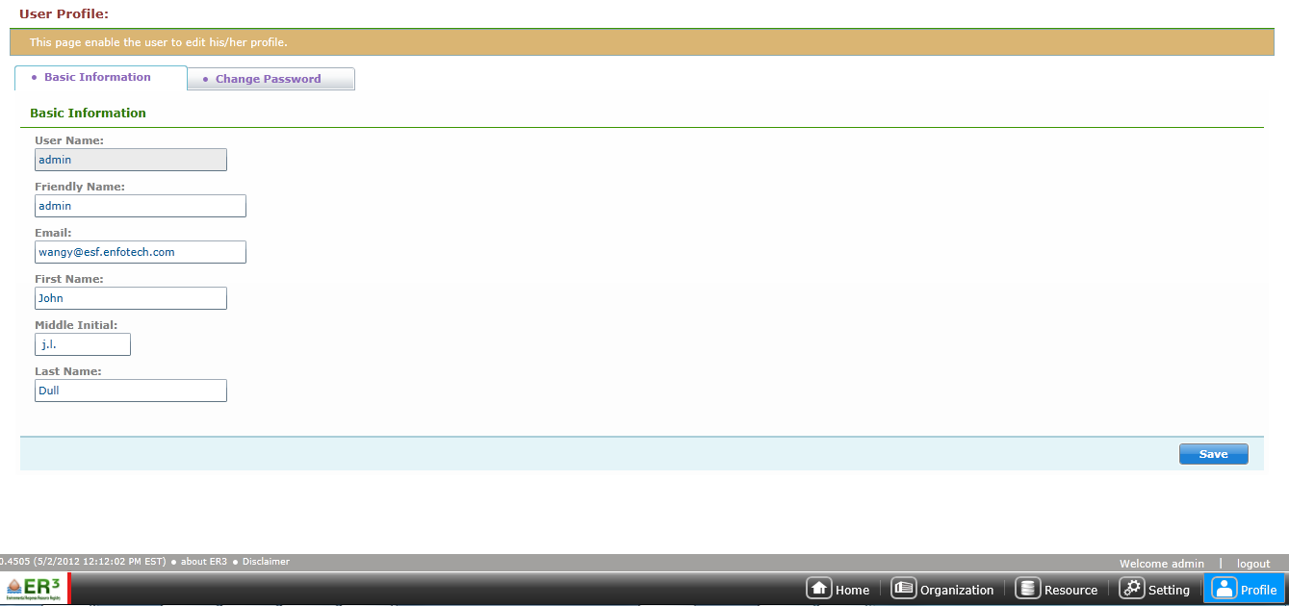

**Figure 17: Profile Management Module**

You may edit your account information in the “Basic Information” tab. In addition, you may change your system password in the “Change Password” tab.

Click the “Save” button to commit your updates.