Virtual Exchange Service Connector 2.0 Setup Guide for Remote-Hosted Partners

# Introduction

The Virtual Exchange Service Connector (VES Connector) is a component for establishing secure network connectivity between virtual node in the cloud and database server in your enterprise environment without opening firewall for any inbound connections. VES Connector only needs outbound connections to Azure Relay (aka Service Bus). It uses several layers of security to safeguard the access:

1. Token Authentication: The virtual node connector connects to the Azure Relay using a secure authentication token.
2. Transport Security: All communications between your node and database server are encrypted and signed through TLS.
3. Application Authentication: Database layer authentication is enforced by the virtual node. All incoming requests to the database servers are authenticated.
4. Node Access: All requests to Virtual Node must be authenticated through NAAS.

The VES Connector can be installed on any Windows Server if it has local network connectivity to the database server.

# System requirements

|  |  |
| --- | --- |
| Component | Minimum Requirement |
| Machine | * **Windows 64-bit** * **Windows Server 2016 or greater, or Windows 10 or greater** * **.NET Framework 4 version 4.6.1 or greater** |
| Database | **Database is required, can be one of:**   * **SQL Server** * **Oracle** |
| Additional Connectivity | * **Azure Relay (aka Service Bus), which requires no changes to firewall rules; or firewall rule for direct connectivity*.*** * **TLS 1.2** |
| Additional Tools | **Tool or process to map data into database** |

# Installation steps

*If a previous version of the VES connector exists, please see the section below regarding Modifying Connector Configuration after Installation.*

1. Download the installation package:
   * <https://ves.epa.gov/VESA/Documents/VesConnectorV2.zip>
2. Extract the package to a folder of your choice on the server.
   * For example: extract to C:\Program Files\EPA.gov\VesConnectorV2
3. Open a configuration file in a text editor.
   * For example: C:\Program Files\EPA.gov\VesConnectorV2\VesConnectorV2.exe.config
4. Update the new config.
   * For example: 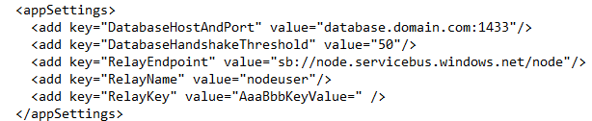
   * For " DatabaseHostAndPort" you will need to specify a database host (server name) and a port (1433 for SQL Server, 1521 for Oracle).
     + For example: database-server.domain.com:1433
   * Please contact the Node Helpdesk ([nodehelpdesk@epa.gov](mailto:nodehelpdesk@epa.gov)) for help with any configuration questions.
5. Locate the folder that contains the InstallUtil.exe utility for installing Windows services at: %WINDIR%\Microsoft.NET\Framework[64]\<framework_version>
   * For example: C:\Windows\Microsoft.NET\Framework64\v4.0.30319
6. Open a command prompt with administrator privileges and navigate to the folder above.
7. Run command:
   * installutil C:\Program Files\EPA.gov\VesConnectorV2\VesConnectorV2.exe
8. Start, type “Services”, and open Windows services (gear icon).
   * Open services.msc and you will find that a new service, VES Connector 2.0, was created and is running. If the service has not started automatically, start it manually. Please contact the Node Helpdesk ([nodehelpdesk@epa.gov](mailto:nodehelpdesk@epa.gov)) for help with any troubleshooting.

# Using the Virtual Exchange Service Connector

Once your connector is up and running, you need register your remote database with your ***Sub Namespace*** and the ***database local IP address*** as shown below.

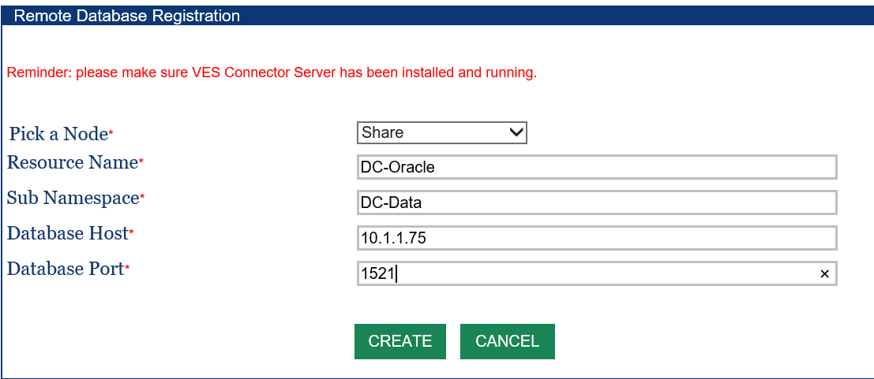

We will assign a special VES Connector port associated with your Sub Namespace. This will be the port to setup your Data Source as shown below. Please consult the Virtual Node Administrator’s Guide on how to setup Data Sources for accessing your databases using the virtual node.

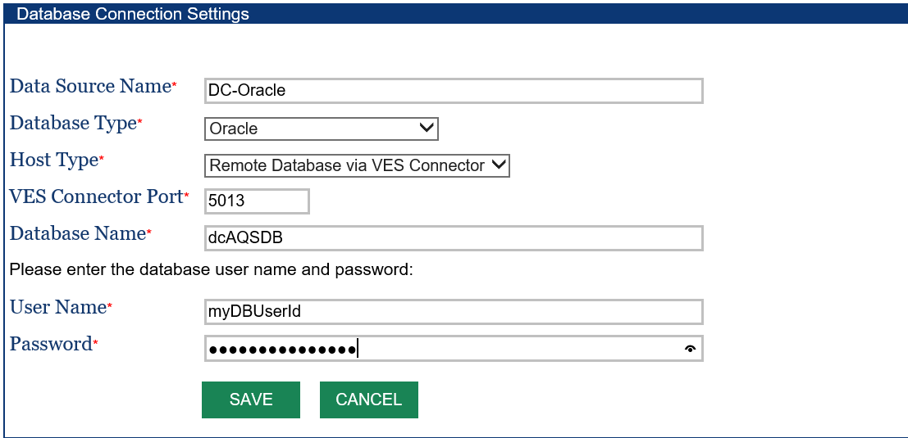

# Trouble Shooting and Support

The VES Connector writes activity and error information in a log file in the directory where it was installed. It usually contains detailed information on exceptions when an error occurs. Please contact Node Helpdesk at [nodehelpdesk@epa.gov](mailto:nodehelpdesk@epa.gov) if technical support is needed.

Although VES Connector does not usually require changes to firewall settings, some states block outbound connections. In these cases, a firewall rule needs to be set as shown below:

* Allow outbound connections from VES Connector to MS ISB server at *.servicebus.windows.net.

# Modifying Connector Configuration after Installation

1. Download the installation package:
   * <https://ves.epa.gov/VESA/Documents/VesConnectorV2.zip>
2. Extract the package to a folder of your choice on the same server that the existing Connector is installed on.
   * For example: extract to C:\Program Files\EPA.gov\VesConnectorV2
3. Locate your configuration file for the existing Connector
   * For example: C:\Program\Files\EPA.gov\VESConnectorServer\VESConnectorserver.exe.config
4. Open a new configuration file in a text editor.
   * For example: C:\Program Files\EPA.gov\VesConnectorV2\VesConnectorV2.exe.config
5. Use your existing config to update the new config, as follows: 
   * issuerName --> RelayName
   * issuerSecret --> RelayKey
   * ServicePath --> RelayEndpoint
   * Allow --> DatabaseHostAndPort
     + If "allow" is blank/empty in the existing config, for the new config, you will need to specify a database host (server name) and a port (1433 for SQL Server, 1521 for Oracle)
     + For example: database-server.domain.com:1433
6. Locate the folder that contains the InstallUtil.exe utility for installing Windows services at: %WINDIR%\Microsoft.NET\Framework[64]\<framework_version>
   * For example: C:\Windows\Microsoft.NET\Framework64\v4.0.30319
7. Open a command prompt with administrator privileges and navigate to the folder above.
8. Run command:
   * installutil C:\Program Files\EPA.gov\VesConnectorV2\VesConnectorV2.exe
9. Start, type “Services”, and open Windows services (gear icon).
10. Scroll down to “VES Connector 2.0” service, right-click, Start.