Virtual Exchange Service Connector Client Setup Guide for CDX-Hosted Partners

# Introduction

The Virtual Exchange Service (VES) Connector Client is a component for establishing secure network connectivity between virtual node in the cloud and database server in your enterprise environment without opening firewall for any inbound connections. VES Connector Client only needs outbound connections to trusted Azure Relay (aka Azure Service Bus). It uses several layers of security to safeguard the access:

1. Token Authentication: The virtual node connector connects to the Azure Service Bus using a secure authentication token.
2. Transport Security: All communications between your node and database server are encrypted and signed through TLS.
3. Application Authentication: Database layer authentication is enforced by the virtual node. All incoming requests to the database servers are authenticated.

The VES Connector Client can be installed on any Windows Server if it has local network connectivity to the database server.

# System requirements

* Windows 64bit system with database server such as SQL Server or Oracle.
* .NET Framework 4 64-bit Full version.

# Installation notes

The VES Connector Client is used to access the database through Azure Relay (aka Azure Service Bus). Before installing the client, you should collect two pieces of information: The service bus configuration and the database configuration.

**Service Bus Configuration:**

|  |  |  |
| --- | --- | --- |
| **Item** | **Description** | **Provider** |
| namespace | This is a unique string to identify the service bus. | CGI (Azure Relay aka Azure Service Bus) |
| issuer | The issuer name of the secret token | CGI (Azure Relay aka Azure Service Bus) |
| token | This is the secret key for accessing the service bus namespace. It is an encrypted string. | CGI (Azure Relay aka Azure Service Bus) |

**Remote Database Configuration:**

|  |  |  |
| --- | --- | --- |
| **Item** | **Description** | **Provider** |
| Remote IP Address | This is the IP address of the database server. It may also be a DNS name of the database server. | CGI (Database Owner) |
| Remote Port | This is port of the database server. | CGI (Database Owner) |
| Local Port | Your local port. This port is mapped to the database server and port. You will connect to the database using this port. | You |

# Installation steps

1. Unzip VESConnectorClientSetup2.0.zip in a proper temporary folder.
2. Uninstall previous version if one exists.
3. Click setup.exe in the temp folder to start the installation.
   1. Click the next button when the first wizard screen is displayed as shown below.  
      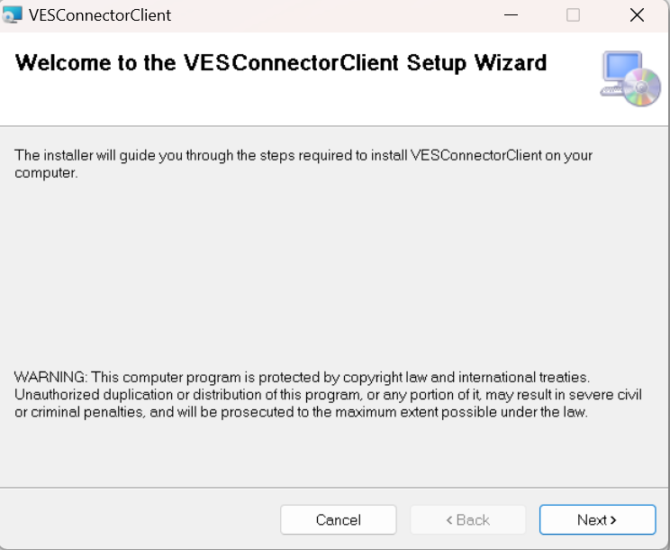
   2. Select a file folder to install the connector or use the default when the second screen is displayed. Then click the next button again.

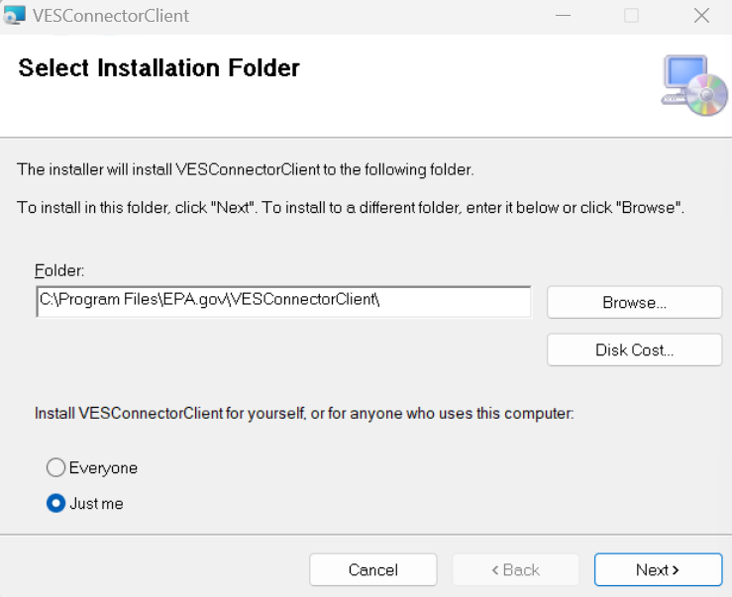

* 1. When the Service Bus Configuration screen is displayed, input namespace, issuer, and token, then click the Next button. 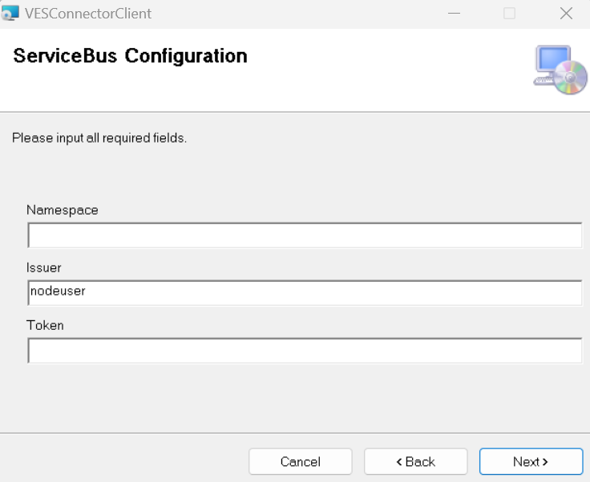
  2. Input the IP address (or DNS name) and port for the database server, e.g. 192.168.0.10 and 1433. The Local Port is the port you are going to use to connect to the database server. Click the next button after completing the form.

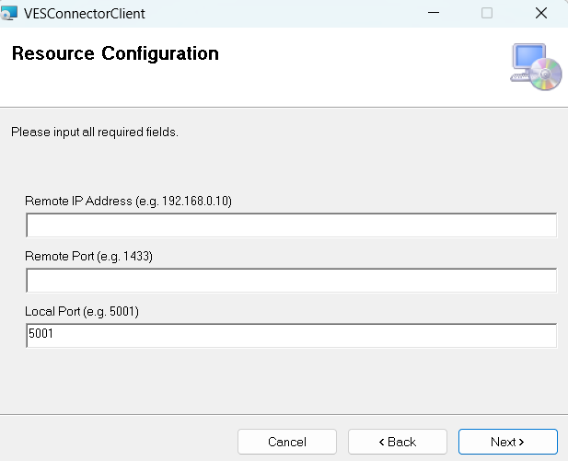

* 1. A warning screen is displayed to allow you double check what was entered. Click the next button.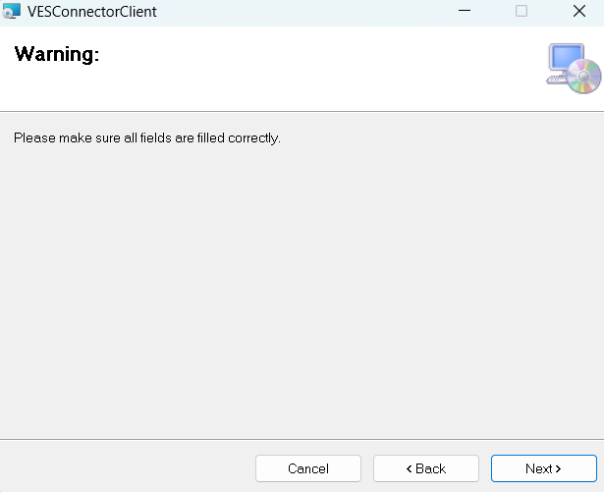
  2. On the Confirm Installation screen, click the next button.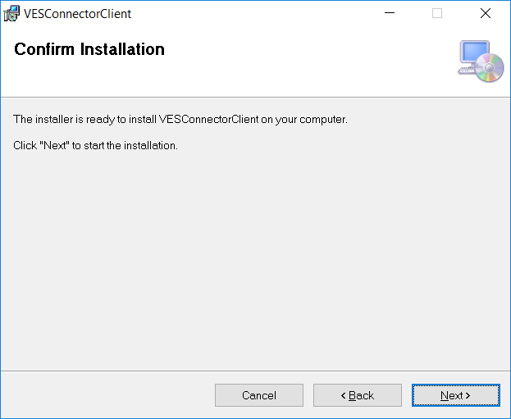
  3. Click “Yes” when the user account control window pops up. Then wait until following screen is displayed. Click close to complete the installation.

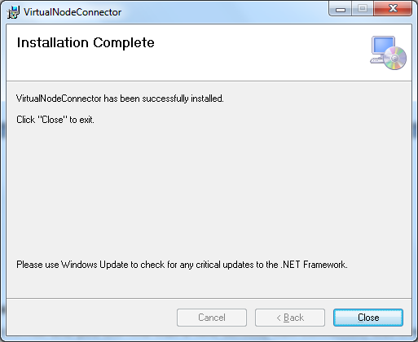

1. Start the windows service.
   1. Open services.msc and you will find that a new service, VES Connector Client, was created and is running. If the service has not started automatically, start it manually. Please contact the Node Helpdesk ([nodehelpdesk@epa.gov](mailto:nodehelpdesk@epa.gov)) for help with any troubleshooting.
2. You can run local database client application to connect to the database server using localhost as the IP address and Local Port as the port (i.e., localhost,5001 when using SQL Server Management Studio).

# Trouble Shooting and Support

The VES Connector Client writes activity and error information in a log file in the directory where it was installed. It usually contains detailed information on exceptions when an error occurs. Please contact Node Helpdesk at [nodehelpdesk@epa.gov](mailto:nodehelpdesk@epa.gov) if technical support is needed.

# Modifying Connector Configuration after Installation

The Virtual Node Connector has a configuration file named

**VESConnectorclient.exe.config**

in the directory where it was installed (the default directory is c:\Program Files\EPA.gov\VESConnectorServer). You may make changes of settings in the AppSettings section. The section contains configuration as shown below:

<appSettings>  
 <add key="issuerName" value="owner"/>  
 <add key="issuerSecret" value="Lx1YSC9DhlENj6vLUqCKeyValue="/>  
 <add key="servicePath" value="sb://nodedb.servicebus.windows.net/cdx"/>

<add key="localAddress" value="0.0.0.0"/>  
 <add key="remoteHost" value="192.168.0.10"/>  
 <add key="remotePort" value="1433"/>  
 <add key="localPort" value="5001"/>  
 <add key="allow" value="MyDB.MyDomain.com:1433"/>  
 <add key="waitMin" value="1"/>  
 </appSettings>

The Items in the configuration sections are:

* **issuerName**: The name of the service bus issuer. It is used for authenticating to the Azure Service Bus.
* **issuerSecret**: This is an encrypted secret for authenticating to the Azure Service Bus. A new set of issuerName and issuerSecret should be used when the servicePath changes. The issuerName and issurerSecret are issued by the Virtual Node host administrators.
* **servicePath**: This is the URL where the Azure Service Bus can be reached.
* **localAddress**: This is the local IP address and can’t be changed.
* **remoteHost**: This is the database IP address or DNS name.
* **remotePort**: This is the database connection port.
* **localPort**: This is the local port, default value is 5001 and it can be changed.