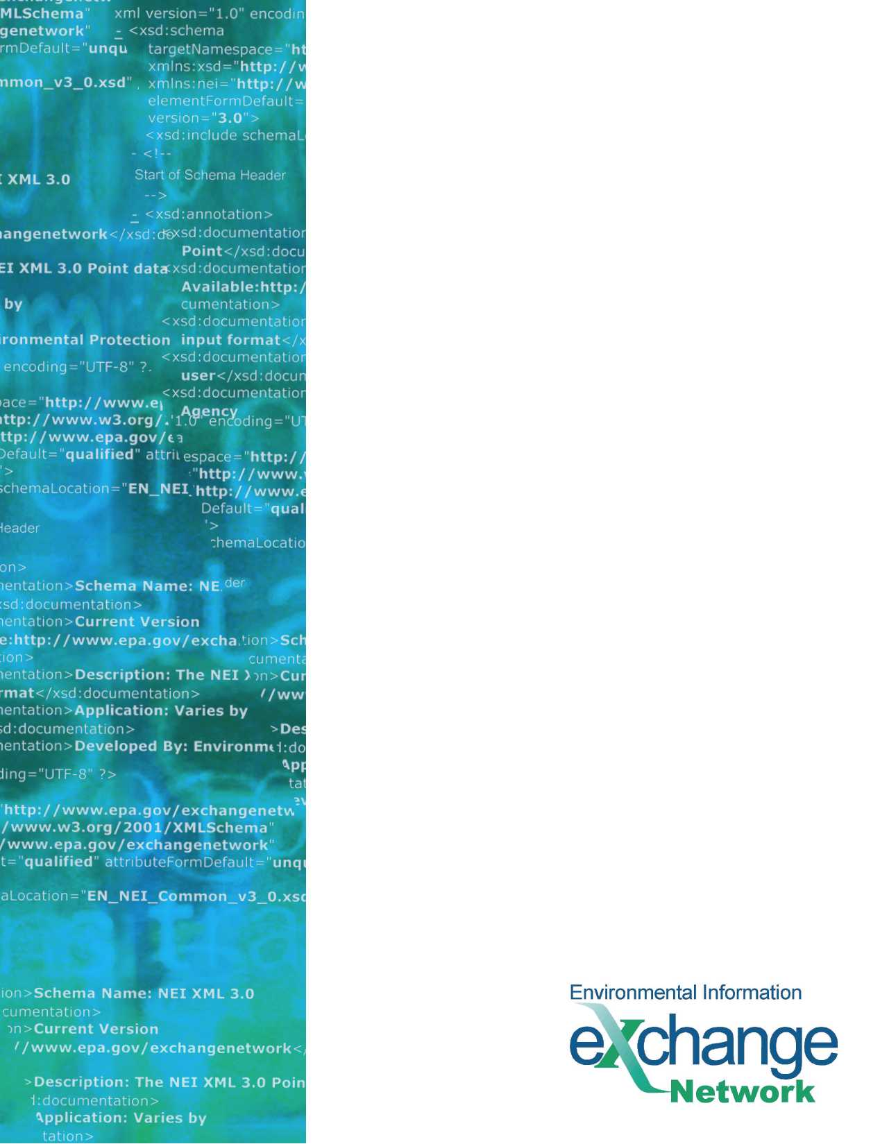

**Virtual Exchange Service (VES) and Exchange Network Services Center (ENSC)**

Frequently Asked Questions

Revision Date: October 29, 2024

THIS PAGE INTENTIONALLY LEFT BLANK

Table of Contents

1 What is the Exchange Network (EN)? 4

2 What is Virtual Exchange Service? 4

3 What is the Exchange Network Service Center? 4

4 What are the Minimum Requirements? 5

4.1 Virtual Exchange Service 5

4.2 Exchange Network Service Center 5

5 Virtual Exchange Service 5

5.1 What are the ‘Services’ Provided by the VES? 5

5.2 What Data Exchanges are Currently Available in the VES? 6

5.3 What is the Virtual Exchange Service Administrator? 6

5.4 What Kind of Security is Available/Required for the VES? 6

5.5 What are the Components or Objects that the VES Provides Virtually? 6

5.6 How do I Administer my Data Flows When Using VES? 7

5.7 Can VES be Used for a Custom Flow (an Exchange not Currently Available in VES)? 7

5.8 What are the Additional Connectivity Requirements for the VES? 8

5.9 Is VES an Option for an Exchange Network Member with Limited Internet Connectivity? 8

5.10 What are the Operations and Maintenance (O&M) Impacts of Adopting the VES? 8

5.11 Can the Node Helpdesk Assist an EN Partner with Getting Started with VES? 9

5.12 What Additional VES Resources are Available? 9

6 Exchange Network Service Center 9

6.1 What Methods Does the ENSC Utilize for the Exchange of Information? 9

6.2 Does the ENSC provide multiple options for using data services? 9

6.3 How can a Partner request access to the ENSC? 9

# What is the Exchange Network (EN)?

The EN is a partnership among States, Local Governments, Tribes, and U.S. Environmental Protection Agency (EPA) that is improving and expanding the exchange of environmental information.

First envisioned in 1998, the EN is an established communication, data, and services platform for sharing environmental information to foster informed decision-making. This network is managed under the collaborative leadership of EPA, States, Territories, and Tribes.

Using the Exchange Network, States, Territories, Tribes, universities, not-for-profit organizations, and others can share data with EPA and other Network Partners securely via the Internet.

More information is available at: <http://www.exchangenetwork.net/about/> and at the searchable Exchange Network Knowledge Base: <http://www.exchangenetwork.net/knowledge-base/>.

# What is Virtual Exchange Service?

The VES is a cloud-based platform for creating data exchanges on the EN. It eliminates the need for Partners to create and maintain a node server. The VES supports all of the functions of a node and simplifies the creation of data exchanges. It also supports a new communication model to simplify connectivity.

The Virtual Exchange Service Administrator (VESA) is a web interface used by Partners to configure their virtual note, dataflow, services, and schedule tasks, etc. With these configurations, data exchange with VES is simply click of the submit button or scheduling tasks that execute data submission automatically.

The VES evolved from the guidance and recommendations from the EN Virtual Node (ENVN) Integrated Project Team (IPT) that was formed to discuss and investigate the adoption of a virtual node platform on the Exchange Network.

More information is available at: <http://www.exchangenetwork.net/virtual-exchange-service/>.

# What is the Exchange Network Service Center?

The ENSC is a browser-based tool designed to allow EN users to easily send, retrieve, and download information from other partners on the network. It supports manual file submission in any format, including common formats such as Extensible Markup Language (XML), JavaScript Object Notation (JSON), and Comma-separated values (CSV).

The ENSC is available at: <https://enservices.epa.gov/>.

# What are the Minimum Requirements?

## Virtual Exchange Service

|  |  |
| --- | --- |
| Component | Minimum Requirement |
| Machine | **Windows 64-bit**  **Windows Server 2016 or greater, or Windows 10 or greater**  **.NET Framework 4 version 4.6.1 or greater** |
| Database | **Database is required, can be one of:**   * **SQL Server** * **Oracle** |
| Additional Connectivity | * **Azure Relay (aka Service Bus), which requires no changes to firewall rules; or firewall rule for direct connectivity*.*** * **TLS 1.2** |
| Additional Tools | **Tool or process to map data into database** |

## Exchange Network Service Center

|  |  |
| --- | --- |
| Component | Minimum Requirement |
| Machine | **Internet-connected computer with modern web browser** |
| Database | **N/A** |
| Additional Connectivity | **N/A** |
| Additional Tools | **Tool or process to create submission documents based on the target format for trading for the data exchange** |

# Virtual Exchange Service

## What are the ‘Services’ Provided by the VES?

The VES uses a ‘services’ approach to accomplish all of the functions associated with the exchange of data over the EN.

For example, the VES has a complete set of prebuilt services to support Integrated Compliance Information System (ICIS)-Air. For ICIS-Air alone, there are multiple services that can be used; services include:

* GetAirFacility/Query – Reads data from the staging tables in the database and creates an XML file.
* SubmitAirFacilityData/Execute – Submits the XML file and receives the associated response information.

## What Data Exchanges are Currently Available in the VES?

The currently available data exchanges can be located on the home page of the VESA.

VESA environments are available at:

|  |  |
| --- | --- |
| Development | <https://vesdev.epacdxnode.net/VESA> |
| Test | <https://vestest.epacdxnode.net/VESA> |
| Production | [<https://ves.epa.gov/VESA>](https://ves.epa.gov/VESA) |

## What is the Virtual Exchange Service Administrator?

The VESA is the web interface that is used to configure data flows. New data flows are created, and data is published by filling out forms, with no coding required. Data exchanges can be imported from a shared version that fills out the forms, allowing Partners to concentrate on mapping data to their staging tables.

VESA environments are available at:

|  |  |
| --- | --- |
| Development | <https://vesdev.epacdxnode.net/VESA> |
| Test | <https://vestest.epacdxnode.net/VESA> |
| Production | [<https://ves.epa.gov/VESA>](https://ves.epa.gov/VESA) |

## What Kind of Security is Available/Required for the VES?

VES is fully integrated with network authentication and authorization service (NAAS) for user authentication and authorization. When a VES (node) is created, it is assigned to an owner; the service owner has full control over who can access each service using NAAS security policies.

Although hosted in the same environment with other nodes, the VES allows only the service owner to make changes to their VES properties and configurations. For example, one administrator will not be able to create a service for another node instance they are not an owner of.

A VES has the same access control mechanisms as any Network node. The node administrator’s authorization is required for accessing node services.

## What are the Components or Objects that the VES Provides Virtually?

A VES has six key objects that its owner can create and manage. They are:

* **Node**: Contains the definition of a VES including its address (endpoint), description, owner, and other properties.
* **Data Source**: Defines an access point where information is supplied. In most of situations, a data source contains database server name, address, login account, and other connection information.
* **Data Flow**: A logical collection of services that deal with a common set of information exchanged between partners (ex. RCRA). A VES owner can create a data flow and set its properties.
* **Service**: A definition of what must be provided. A VES owner adds new features to a network node by creating services. The services are the basic operation unit that a node executes at runtime.
* **Task**: A set of operations to be executed automatically on a scheduled basis. For instance, a task can be created to perform quarterly submissions to a CDX data flow.
* **Document Header**: A document header is information appended to the heading of a newly created document when a service is executed. This header information is used at the beginning of a document upon the completion of constructing instance documents, which includes any query results and it’s corresponding eXtensible Stylesheet Language Transformations (XSLT).

## How do I Administer my Data Flows When Using VES?

The VESA provides a web interface to allow provisioning and maintenance and data flows. In addition to the web interface, a Simple Object Access Protocol (SOAP) application program interface (API) is available. The API that allows administrative functions to be scripted or integrated into other applications.

The VES Virtual Node Administrator’s Guide is available at: <http://www.exchangenetwork.net/virtual-exchange-service/>.

## Can VES be Used for a Custom Flow (an Exchange not Currently Available in VES)?

Yes – VES can be used to exchange data with partners. For example, to publish database information as web services, create an SQL statement and VES will construct an XML document accordingly. Users may convert the XML into any other format using a stylesheet. VES offers many examples as templates that can be customized to meet specific requirements.

The flow is configured manually through the completion of forms instead of shared templates. VES offers a set of common workflows and handles transaction-related tasks as part of its core capabilities.

Partners, who utilize custom flows, can test or submit data flows directly from VESA. If the action is a query, partners can access it either from the ENSC or from an Internet browser using the flows-associated representational state transfer (REST) Uniform Resource Locator (URL). The owner of the VES node must authorize Partners through NAAS policies. The EN Node Helpdesk can be contacted at: [nodehelpdesk@epa.gov](mailto:nodehelpdesk@epa.gov), for support on NAAS security policies and services.

REST services are created for all publishing services (queries) in addition to the Simple Object Access Protocol (SOAP) service. These can be made accessible from any browser with or without authentication.

## What are the Additional Connectivity Requirements for the VES?

Before creating a data source, there must be network connectivity from the VES to the database server. Connectivity options are:

* **Azure Relay (aka Service Bus):** A network agent (or adapter) called the VES Connector is provided to relay network traffic between the network node and an authenticated local database server. This is the preferred option as the VES Connector provides secure network connectivity without changing firewall rules.

It is the responsibility of a VES owner to establish network connectivity. The VES engineer and EN Node Helpdesk, at: [nodehelpdesk@epa.gov](mailto:nodehelpdesk@epa.gov), will provide assistance as needed.

The Virtual Exchange Service Administrator’s Guide is available at: <http://www.exchangenetwork.net/virtual-exchange-service/>.

## Is VES an Option for an Exchange Network Member with Limited Internet Connectivity?

Yes – connectivity does not have to be on always. However, connectivity should be on whenever possible if the VES is used for data publishing so that a Partner can access the service at any time. The VES is resilient to network disruptions because many retry mechanisms have been built into its business process.

## What are the Operations and Maintenance (O&M) Impacts of Adopting the VES?

The traditional O&M burdens for server and node maintenance are eliminated under the VES. The O&M for Network Nodes is performed under VES.

Data flow maintenance may still exist. If a new data flow version is released, some maintenance steps may be required. Under VES, the maintenance required for similar data flow changes, under traditional interface and node architectures, can be reduced. Maintenance may include steps such as:

* Create new staging tables (using scripts for the data flows with existing templates)
* Remap source data to a new staging table structure
* Import and update the latest template from VES

## Can the Node Helpdesk Assist an EN Partner with Getting Started with VES?

The Exchange Network Node Helpdesk ([nodehelpdesk@epa.gov](mailto:nodehelpdesk@epa.gov)) can walk a Partner through the establishment of a VES administration account that is authorized to manage VES with the VESA. The Node Helpdesk can also help organize a meeting with VES engineers to help assess a Partner’s needs. Additionally, introductory VES guidance can be provided.

## What Additional VES Resources are Available?

Extensive documentation is available at: <http://www.exchangenetwork.net/virtual-exchange-service/>.

In addition, the initial startup phases of a VES effort typically include collaborative meetings with interested EN Partners and VES engineers. VES engineers explain documentation and provide continuous custom support to ensure that EN Partners are successful in their VES implementations.

# Exchange Network Service Center

## What Methods Does the ENSC Utilize for the Exchange of Information?

The ENSC utilizes three methods for the exchange of environmental information:

* **Send Info:** Submit documents or information to another system on the EN.
* **Get Info:** Retrieve information from another system on the EN. This information is either retrieved immediately through query services or requested and then downloaded through solicit services.
* **Download:** Download a document from another system on the EN with a transaction or document identification (ID).

## Does the ENSC provide multiple options for using data services?

Yes, the Exchange Network Service Center provides two options for using data services.

* **Guide Me Step-by-Step** guides more novice users through the steps necessary to complete the transaction.
* **Express Request** allows advanced users to quickly complete their transaction.

The Service Center tracks a user’s previously utilized services and past activity to ease future access.

## How can a Partner request access to the ENSC?

The EN Node Helpdesk ([nodehelpdesk@epa.gov](mailto:nodehelpdesk@epa.gov)) can walk a Partner through the establishment of an account that is authorized to access the ENSC.