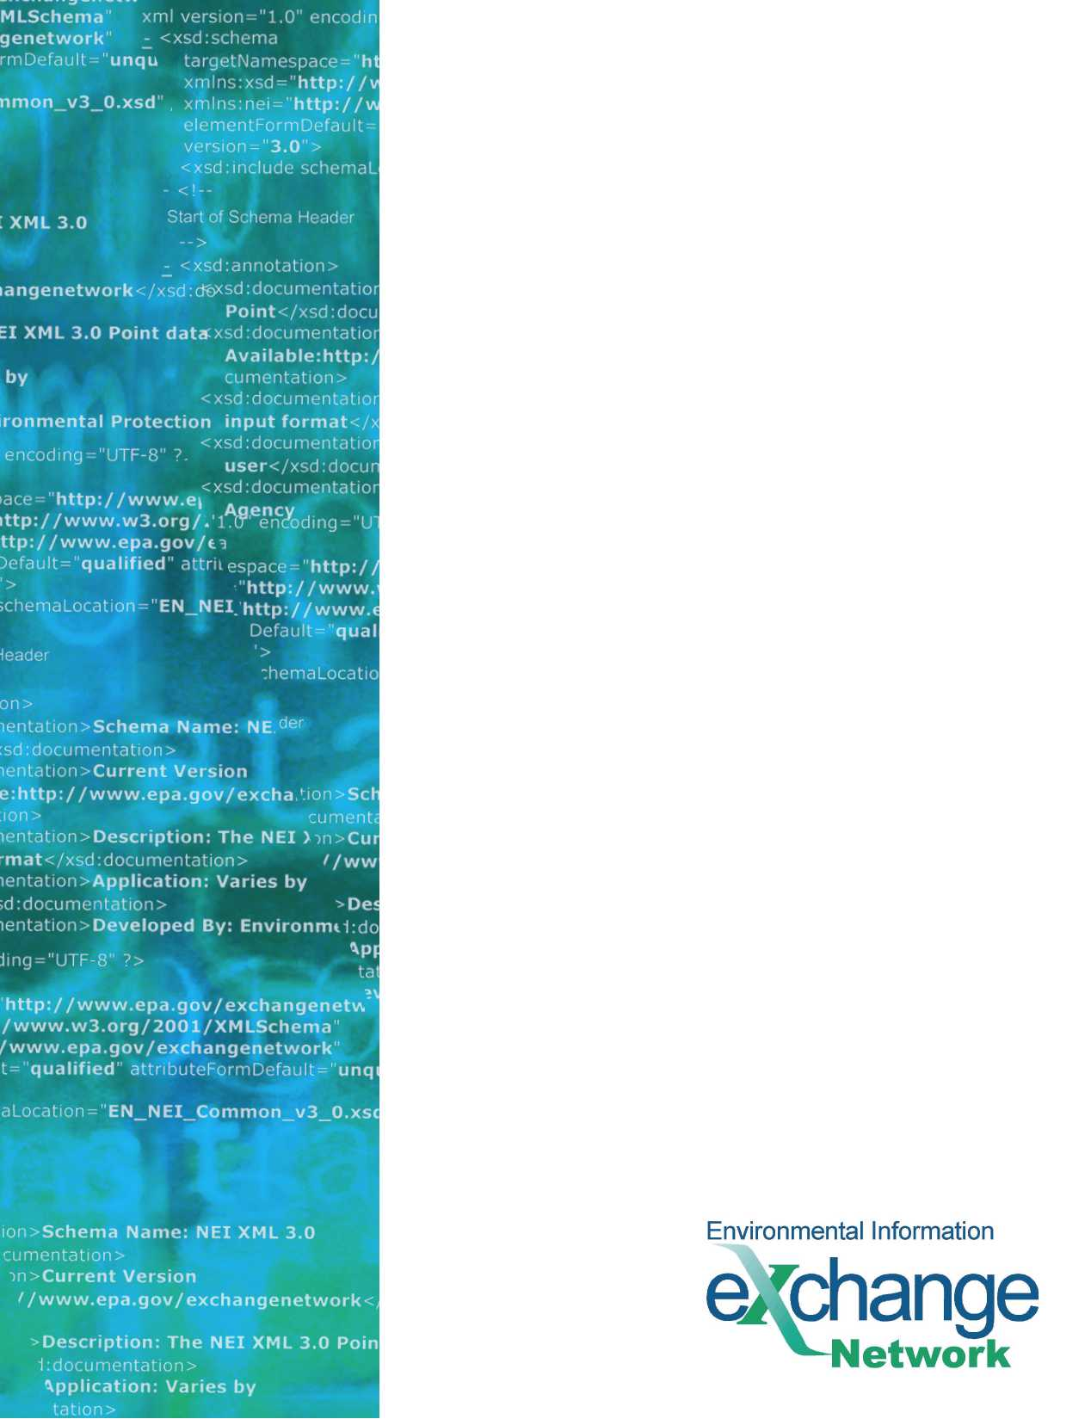
Combined Air Emissions Reporting System (CAERS)

Flow Configuration Document

Version: 1.0
Revision Date: August 9, 2023

THIS PAGE INTENTIONALLY LEFT BLANK

Table of Contents
Table of Contents 3
1 Component Alignment 4
1.1 Flow Component Versions Currently Supported 4
2 Introduction 5
2.1 Flow Identification 5
2.2 Background 5
2.3 Data Flow Overview 5
2.4 Flow-level Business Rules 5
2.5 Additional Flow Tools and Resources 5
3 Data Access Services using Representational State Transfer (REST) 7
3.1 Access / Authorization 7
3.2 Services 7
3.2.1 Error Handling 8

Component Alignment

Flow Component Versions Currently Supported
Component | Version(s) Supported | Explanation
FCD | 1.0 | Initial version
Schema | 1.0 | Initial version
DET | 1.0 | Initial version

Introduction

Flow Identification
Flow Name:
Combined Air Emissions Reporting System (CAERS)
Flow Owner:
U.S. Environmental Protection Agency (USEPA) / Office of Air Quality Planning and Standards (OAQPS), Air Quality Assessment Division (AQMD), Emissions Inventory and Analysis Group (EIAG)
Flow Owner Contact Information:
Julia Gamas
USEPA / OAQPS, AQMD, EIAG
Phone: (919) 541-7915
Email: gamas.julia@epa.gov

Background
The Combined Air Emissions Reporting System (CAERS) is an application that allows industry from subscribed State, Local, or Tribal authorities (SLTs) to report air emissions to:
- Meet specific SLT air emissions reporting requirements given individual SLT regulations;
- Report annual or triennial emissions to meet the requirements of the U.S. EPA’s Air Emissions Reporting Rule (AERR), as per the Code of Federal Regulations (or CFR) 40, Part 51; and
- Optionally, get a head start on reporting toxics air emissions to the U.S. EPA’s Toxics Release Inventory (TRI), as per 40 CFR Part 372.

Data Flow Overview
CAERS provides outbound data access services that enable SLT authorities to download air emissions data that was reported by their industry in CAERS. These outbound services provide CAERS reporting data using the same JavaScript Object Notation (JSON) schema used within the CAERS application to upload reporting data.

Flow-level Business Rules
The CAERS Data Exchange Template (DET) contains the list of data elements and their respective business rules. It is recommended that users familiarize themselves with the DET to understand the CAERS JSON structure and applicable business rules.

Additional Flow Tools and Resources
This FCD is intended to define the supported data access services, as well as the approaches and processes that are used to exchange information and is intended to be used in conjunction with the following support documents:
- CAERS DET: Provides the relevant schema data elements for each CAERS module. EPA has included the applicable business rules as they apply to CAERS users. The DET is designed to make retrieval, processing, and upload of CAERS data in the JSON format easier and more understandable.
- Swagger UI: SLT partners can use the CAERS Swagger UI to easily interact with and understand the CAERS API detailed within the OpenAPI spec.
- OpenAPI Spec: This YAML file details the input parameters, outputs, and authentication for the CAERS’ REST API.
This document, and all other relevant documentation, can be found on the Exchange Network website.

Data Access Services using Representational State Transfer (REST)
CAERS has exposed REST publishing capabilities for the CAERS SLT partner community. This capability allows SLTs to retrieve air emissions data that was reported by their industry in JSON format. The JSON schema is the same as the one used to upload data into the CAERS application.

Access / Authorization
All service requests must be accompanied by a valid OAuth security token per the OAuth 2.0 specifications. All partners must be authorized to use the OAuth service and receive valid security credentials for CAERS before any of the CAERS data services can be invoked. These CAERS OAuth security credentials should be requested from the Node Help Desk and are separate from a partner’s CDX account or OAuth credentials used for other Application Programming Interfaces (APIs). Contact nodehelpdesk@epacdx.net to initiate the request and include the following information:
- Full Name
- State, Local, Tribal Agency Name
- Agency Acronym (EIS Program System Code)
- Work Address
  - Address
  - City
  - State
  - ZIP Code
- Email Address
- Phone Number
- CDX Environment (e.g. TEST, PROD)
Partners must use their CAERS OAuth credentials to generate an OAuth token that will be included in the header of their REST calls to CAERS. The Uniform Resource Locators (URLs) in the below table will be used to generate the token. The token will expire after a period of time specified by the token and must be refreshed once it expires.
Environment | Base URL
Pre-production | https://cdxapitest.epacdx.net/oauth/token
Production | https://cdxapi.epa.gov/oauth/token

Services
CAERS REST services are documented in the Swagger UI for each environment with details about how they are used and allowed parameters. This information can be found using the following URLs:
Environment | Base URL
Pre-production | https://cdxappstest.epacdx.net/cef-web/swagger-ui/index.html
Production | https://cdxapps.epa.gov/cef-web/swagger-ui/index.html

Error Handling
In case of an error, REST services will respond with an HTTP error code and JSON containing application error code and message. The following is a sample HTTP error with JSON response:
{
"timestamp": "2023-05-24T18:03:10.762+00:00",
"status": 500,
"error": " Internal Server Error",
"message": "There was an unexpected error",
"path": "/cef-web/api/public/export/report/12"
}

Common Error Codes:
HTTP Error Code | Message
400 | Invalid request arguments
401 | No security token present
401 | Security token is expired
403 | Access denied
500 | There was an unexpected error. Please try again or contact the helpdesk if there are repeated failures.

